**SPRINT -1**

**Project Name:**

**Early detection of chronic kidney disease using Machine Learning.**

**Team ID:**

**PNT2022TMID18970**

**HOMEPAGE**

**This page contains subpages such as Details, Awareness, Diagnosis and Prediction.**

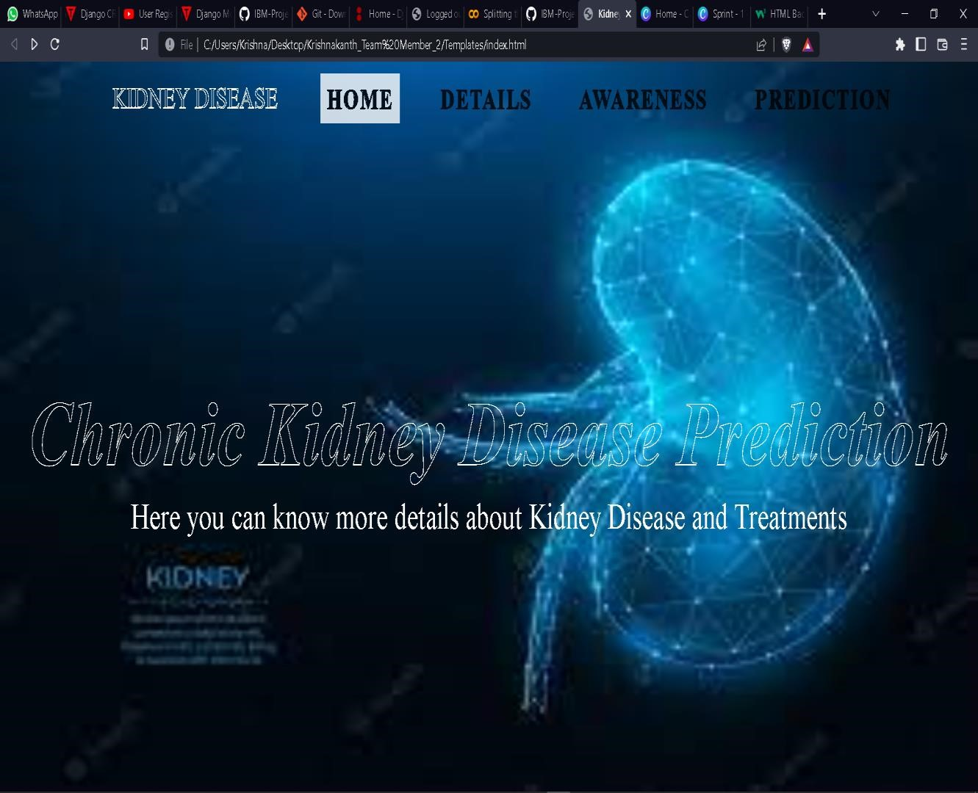

**DETAILS PAGE**

**This page contains information about CKD.**

